### **Twitter Bootstrap**

**Ques1. Webpage Design**

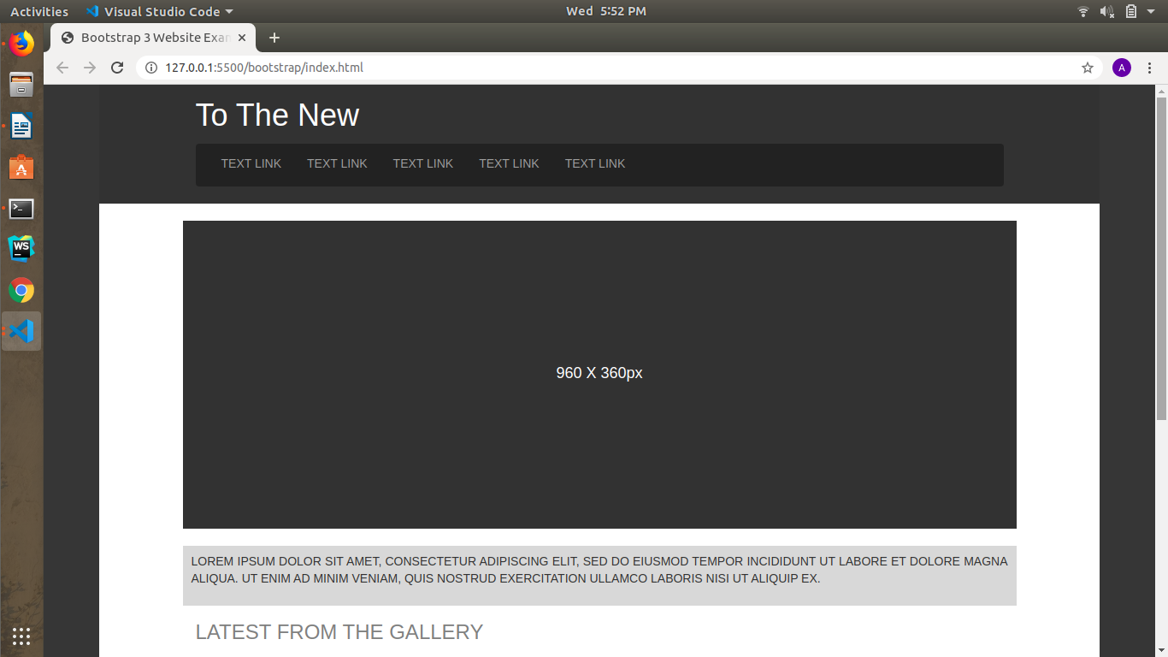

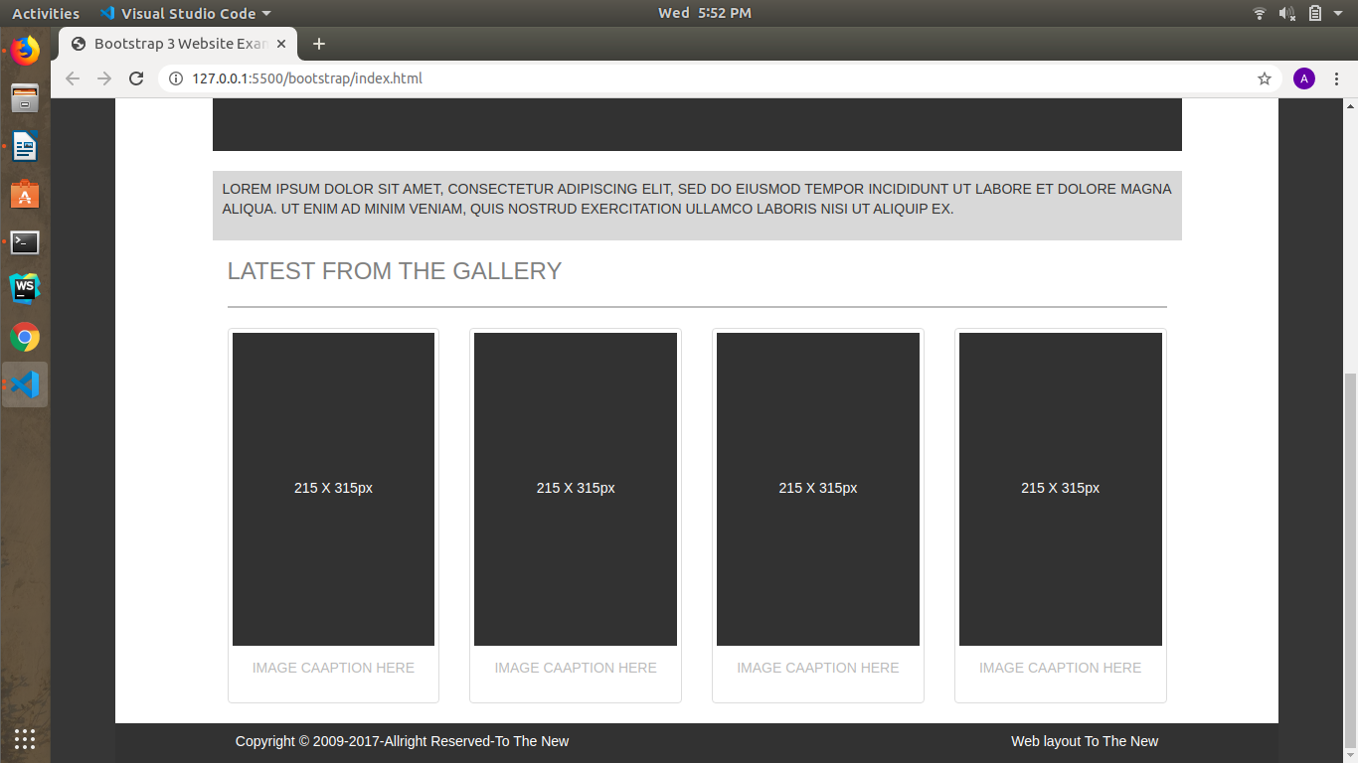

**Ques2. Form Design.**

